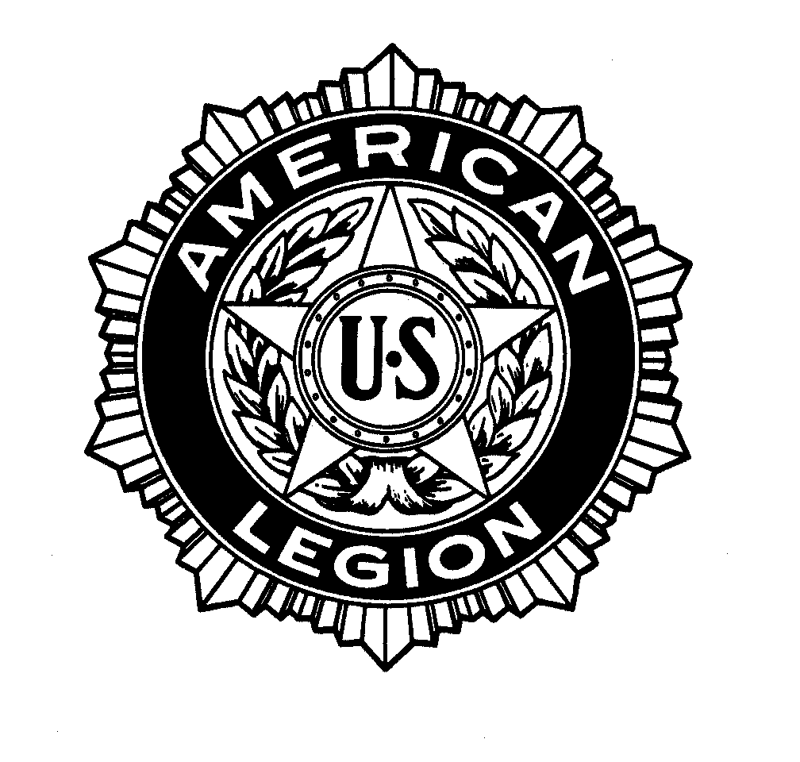

Statement of
JACOB B GADD, deputy director for HEALTH CARE
veterans affairs and rehabilitation commission
the american legion

before the

COMMITTEE ON VETERANS’ AFFAIRS
United states House of representatives

on

“ELECTRONIC HEALTH RECORD U-TURN: ARE THE VA AND DOD HEADED IN THE WRONG DIRECTION”

February 27, 2013

STATEMENT OF
JACOB B. GADD, DEPUTY DIRECTOR FOR HEALTHCARE,
VETERANS AFFAIRS AND REHABILITATION COMMISSION
THE AMERICAN LEGION
BEFORE THE COMMITTEE ON VETERANS AFFAIRS
ON
“ELECTRONIC HEALTH RECORD U-TURN: ARE VA AND DOD HEADED IN THE WRONG DIRECTION”

February 27, 2013

“I’m asking the Department of Defense and the Department of Veterans Affairs to work together to define and build a seamless system of integration with a simple goal: when a member of the Armed Forces separates from the military, he or she will no longer have to walk paperwork from a DoD duty station to a local VA health center; their electronic records will transition along with them and remain with them forever.” - President Barack Obama April 9, 2009

It began as a simple goal, something seemingly well within the grasp of a modern, twenty-first century nation – create a seamless, single health record for veterans. Sadly, four years and a billion dollars later, veterans are left with the feeling their government is throwing in the towel. Veterans are left with the feeling that the two great agencies they have served in and been served by, the Department of Defense (DOD) and the Department of Veterans Affairs (VA), have been unable to come to a simple compromise that would have provided a single, unified record. According to a February 5, 2013 press conference involving both Secretary Panetta of DOD and Secretary Shinseki of VA, a stop gap measure to access both record systems will be put in place and both VA and DOD will continue to maintain and use their legacy systems. This is not what the veterans of America were promised.

Chairman Miller, Ranking Member Michaud and distinguished Members of the Committee:
The American Legion is grateful for the opportunity to come before you today and represent the views of our 2.4 million members on this topic. This is a decision that will have a lasting impact on the entire veterans’ community, as well as on active duty service members serving today and the men and women of the future who have yet to answer the call to serve.

The American Legion supported the creation and implementation of a Virtual Lifetime Electronic Record (VLER). The veterans and service officers of our organization saw firsthand the vital need for seamless communication between VA and DOD. In a resolution passed at our National Convention in Milwaukee, WI in the summer of 2011, not only did our members call for implementation of this record as soon as 2013, we also supported the concept strongly enough to note features such a record should include to be of best use to veterans.

The American Legion recommended Veterans Service Organizations (VSOs) and other key stake holders be included in the planning process so we could share our vital experience in the implementation of VLER. Yet VSOs have been left out of the majority of planning. We called for a single system to improve communication between VA, DOD and elements of VA such as the Veterans Benefits Administration (VBA), Veterans Health Administration (VHA) and National Cemetery Administration (NCA) yet this does not appear to be any part of the integrated plan moving forward. The American Legion supported innovation within this system to improve scheduling for veterans’ appointments with their healthcare system, yet VHA still struggles with timely appointments for veterans.

The American Legion recommended specific ways in which VLER could help veterans with receive the benefits they earned with their service and sacrifice. With a truly integrated record, when a service member was injured or took ill on active duty, their record could be flagged automatically. Years later, following discharge from service, when VA went back to look at the single, unified record, those flags would stand out and make service connection for those disabilities, a benefit earned by the veteran, far easier and less time consuming. Because VA and DOD steadfastly cling to their previous legacy system, it seems likely this will be impossible and the true benefit of technology cannot be implemented on behalf of the veteran.

Veterans’ healthcare records are hurting the disability claims process. This is happening at every level, from currently transitioning veterans to veterans who have been out of service for come time. Improving the healthcare records will help the claims process and will aid VA in their goal to break the back of the backlog. Most importantly, it will help veterans get the benefits they deserve in the timely fashion they deserve.

Current service members transitioning out of the military for medical reasons are experiencing lengthy delays in the Medical Evaluation Board (MEB)/Physical Evaluation Board (PEB) process. The average number of days pending for an MEB/PEB case is 374 days. Much of the delay time involves medical records and scheduling appointments. These are service members who have not even left service yet, and the delays with records are impacting their claims.

When they go to transition, even greater problems arise. During an American Legion visit to a DOD/VA Joint Venture site Legion staff had the opportunity to interview veterans about the transition process. One veteran expressed that the transition process had actually worked very well, “except for my records.” The veteran explained “I enrolled in VA and they asked me for my DOD treatment records [because they did not have access to them]. I walked over to DOD and they told me the base had run out of paper to print the record and to come back in a few weeks.” That our government could not handle this extremely basic task during the transition period for a veteran should be a source of national embarrassment.

The American Legion’s work on the Fully Developed Claims (FDC) pilot project has shown what an impact having quick, easy access to records can have. These claims require getting all of the information together up front to expedite the process for veterans, something that would be improved for all veterans if there was a single, unified electronic record. While the average days pending for regular claims in the system is 257 days, in the FDC program, claims are averaging 120 days, which is under Secretary Shinseki’s stated goal of 125 days for a veteran’s claim. Furthermore, in some locations, such as Pittsburgh, The American Legion has been seeing claims decided accurately in 30-35 days. This is the impact of having all the useful information available right up front for VA. This can be the key towards breaking the backlog.

The American Legion recognizes that some benefit has come from the collaboration. There has been some improvement in communication between VA and DOD over the past four years, although there is certainly room for much more. The collaboration on this project has led to some beneficial results for veterans in the form of eBenefits Portal, the “Blue Button” which allows for the download of healthcare information and some improvement to transition. However, in the end, the veterans are still not receiving what they were promised – a single, integrated system to track their health from the moment they volunteer to serve to the time their families must access their earned benefits from the National Cemetery Administration.

While VA and DOD may still be pursing improved communications, they have abandoned the Integrated Electronic Health Record (iEHR) and that should justly raise an alarm amongst the veterans’ community. This may save money now, but it wastes a portion of the billion dollars already spent. Furthermore, as illustrated by the impact of having readily accessible records in the claims process, it’s an abandonment of technological solutions to the difficult problems the claims system faces.

Veterans should be able to expect 21st century technological solutions that are forward looking, not a retreat to the legacy of the past where VA and DOD maintain their own separate camps. The men and women who serve chose to serve one government, so one government should be able to deliver one healthcare record to them. This technology should not be out of our grasp.

I thank you on behalf of The American Legion for the opportunity to provide our viewpoint on this critical matter.

EXECUTIVE SUMMARY OF THE
STATEMENT OF
JACOB B. GADD, DEPUTY DIRECTOR FOR HEALTHCARE,
VETERANS AFFAIRS AND REHABILITATION COMMISSION
THE AMERICAN LEGION
BEFORE THE COMMITTEE ON VETERANS AFFAIRS
ON
“ELECTRONIC HEALTH RECORD U-TURN: ARE VA AND DOD HEADED IN THE WRONG DIRECTION”

The Department of Defense (DOD) and the Department of Veterans Affairs (VA) may still be moving forward with some stop gap measure to allow for access to veterans’ health records, but it breaks the promise of a single record from the start of their military career throughout their life. This is important because a single unified record will help streamline the benefits process and allow for improved treatment and health care as they access the VA and DOD systems.

- Having all of the records up front drastically reduces processing time for claims and will help slash the claims backlog. The American Legion has seen this first hand through our work on the Fully Developed Claims program.
- By abandoning a single, unified record, key functionality, such as the ability to “flag” a file when a veteran is injured or takes ill on active duty, will hurt the claims process and the ability for any caregiver accessing the file to have a full disability picture of the veteran and render the best possible care.
- Ultimately, this is not what veterans were promised, and furthermore to abandon this project after a billion dollars worth of development with little to show for it is a breach of trust.
- The American Legion recognizes VA and DOD are still working to some kind of solution, and applauds them for the progress made on some components, such as the eBenefits portal, however we urge them to keep their promise to veterans and deliver the single record the veterans deserve.

BIOGRAPHY FOR
JACOB B. GADD
DEPUTY DIRECTOR FOR HEALTH CARE
NATIONAL VETERANS AFFAIRS AND REHABILITATION COMMISSION

Jacob B. Gadd was appointed Deputy Director of The American Legion’s Veteran Affairs and Rehabilitation (VA&R) Division in June, 2010. He is responsible for overseeing five national field service representatives that conduct site visits of the Department of Veterans Affairs (VA) Medical Facilities in conjunction with The American Legion’s “System Worth Saving” Program. The site visits are compiled into the “System Worth Saving” Publication which is submitted annually to the White House, Congress, VA officials and fellow legionnaires regarding the status of VA healthcare. Mr. Gadd also provides veterans analysis, advocacy and training on all Veterans Health Administration (VHA) trends and policies.

Prior to his current position, Mr. Gadd served as the Assistant Director for Program Management of The American Legion’s VA&R division since December, 2006. In this position, Mr. Gadd was responsible for managing the resolution portfolio for the VA&R Commission and served as the Chairperson of the Department of Veterans Affairs Voluntary Service (VAVS) National Advisory Committee. He began working for The American Legion in 2005 as a Field Service Representative.

From 1998-2003, he served in the United States Navy as a Hospital Corpsman. Mr. Gadd assisted with the opening of Portsmouth Naval Hospital, served with the Marine Corps in Camp Lejuene, North Carolina and was stationed overseas in Naval Air Station Sigonella, Sicily.

Mr. Gadd, and his wife and daughter reside in Virginia. Mr. Gadd is also an active legionnaire who assisted in the revitalization of The American Legion George Washington Post 1 in Washington DC.

