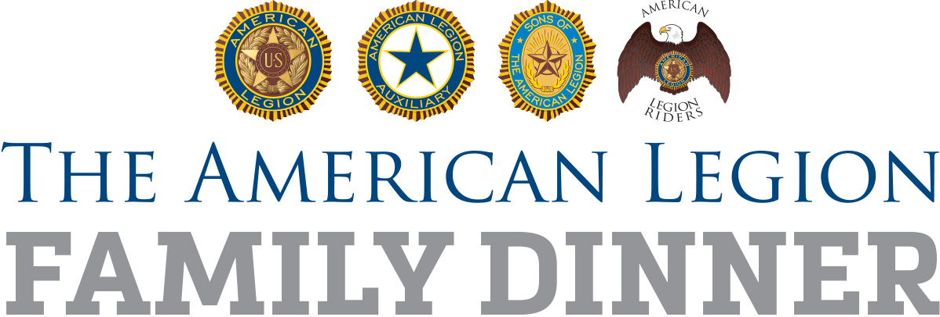
(DATE)

(CONTACT NAME)
(ORGANIZATION OR GROUP)
(ADDRESS)

Dear (LAST NAME):

My name is (YOUR NAME), and I am (YOUR TITLE) of (NAMESAKE) American Legion Post (POST NUMBER) in (CITY, STATE). I am writing to invite (ORGANIZATION OR GROUP) to the post’s Legion Family dinner on (DATE) at (POST OR EVENT LOCATION). This special dinner, in honor of (OCCASION), begins at (TIME).

Healthy families enjoy dinner at the same table together, and we consider the entire community to be members of The American Legion Family.

For nearly 100 years, The American Legion has served veterans, their families, communities, states and the nation. We look forward to discussing during the dinner our legacy of service and our vision for the future, as well as honoring veterans and their families on this special day.

If you could ask around in your group and let us know how many people will be attending, that would be greatly helpful. In addition to your presence, any assistance you would be willing to give toward the dinner – such as volunteer help, donations to help offset costs, etc. – would be greatly appreciated. If you have any questions, feel free to contact me at (PHONE NUMBER) or (EMAIL).

We look forward to seeing members of (ORGANIZATION OR GROUP) at our special Legion Family dinner.

Sincerely,

(YOUR NAME)
(YOUR TITLE), (NAMESAKE) American Legion Post (POST NUMBER)

