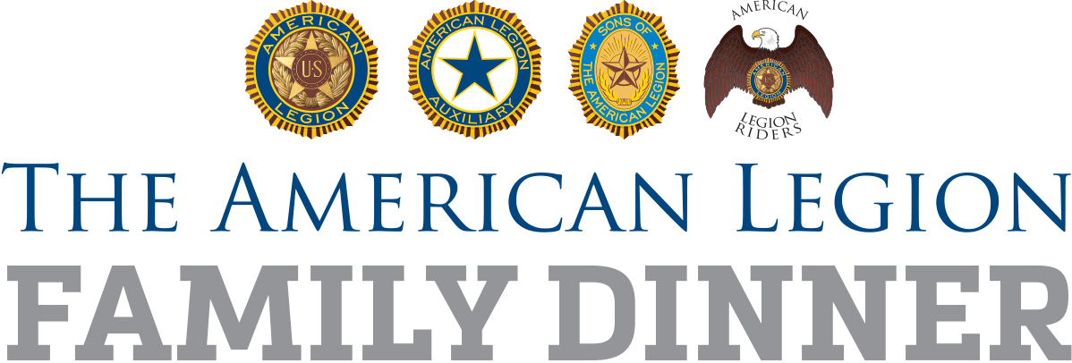

For Immediate Release Date

Sample Media Advisory

American Legion Post (POST NUMBER) Legion Family Dinner

WHO American Legion (NAMESAKE) Post (POST NUMBER)
WHAT The American Legion Family of Post (POST NUMBER) is celebrating (OCCASION) with a dinner, and the entire community is invited to join in. During the dinner, learn about the post’s history of service, current programs and vision for the future.
WHEN (DATE) (LOCAL START TIME)
WHERE (ADDRESS, CITY)
WHY The American Legion is the nation’s leading advocate for veterans, strong national defense, wholesome youth programs and patriotism. Post (POST NUMBER) fulfills its commitment to service since through programs such as (SHORT LIST OF YOUR MOST HIGH-PROFILE PROGRAMS).
HOW Learn more online at (WEBSITE ADDRESS)
Call (NAME AND PHONE NUMBER)

Contact: (NAME, PHONE NUMBER)

