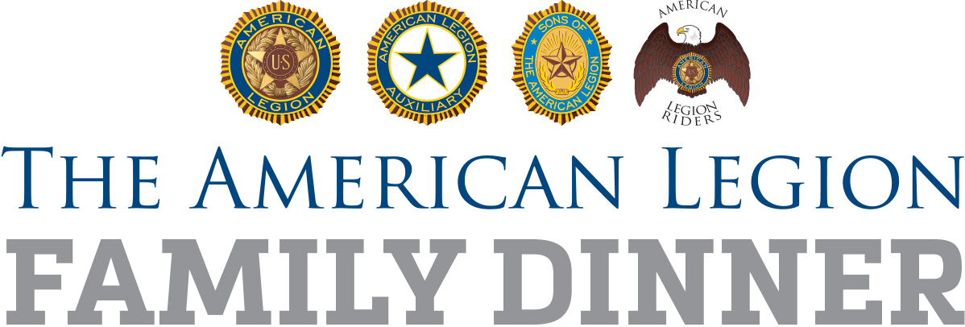

For Immediate Release [Date]

American Legion Post (POST NUMBER) to serve Legion Family Dinner for Community

(CITY) (MONTH DATE, YEAR) – To celebrate (NAME OCCASION) this year, American Legion Post (POST NUMBER) in (CITY) is planning a Legion Family Dinner and inviting the entire community.

Post (POST NUMBER), named for (NAMESAKE), currently numbers XXX members plus XXX in the affiliated American Legion Auxiliary and Sons of The American Legion. It was founded in (YEAR). Among those whose lives have been touched by Post (POST NUMBER) are: (BOYS STATE ALUM, BASEBALL PLAYER, FAMILY, SOLDIER, PUBLIC OFFICIAL, ETC.)

(PROVIDE DETAILS OF DINNER; WHAT, WHERE AND WHEN; ANY COST) The dinner is provided with help from (LIST VOLUNTEER GROUPS, SPONSORS).

“The American Legion Family of (POST and UNIT) is excited to open our doors to the community,” Post (POST NUMBER) Commander (FULL NAME) said. “This event will not only honor veterans and their families, but emphasize our past, present, and future of service to the community.”

Let Post (NUMBER) know you’ll be there by contacting (NAME, PHONE NUMBER, EMAIL ADDRESS).

#LegionFamilyDinner

###

