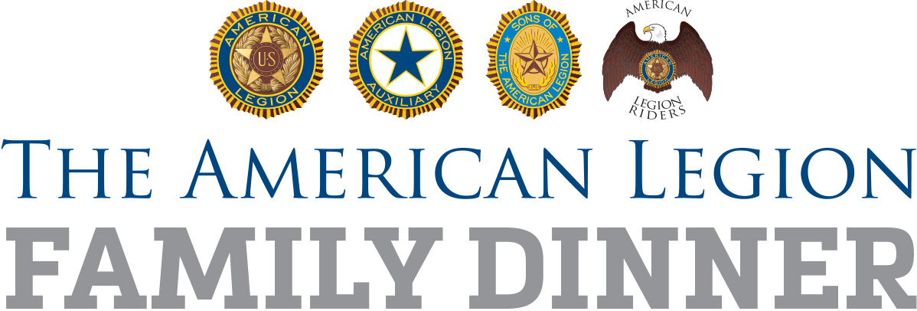

Social media posts

[Good for local Facebook, Twitter, Instagram, feeds; amend as needed/required by platform restrictions]

FACEBOOK

On (DATE), (NAMESAKE) American Legion Post (POST NUMBER) in (TOWN) invites the community to our Legion Family Dinner! (TIME), at the post, (ADDRESS). #LegionFamilyDinner

TWITTER

Legion Family Dinner @AmericanLegion Post (POST NUMBER) in (TOWN). (DATE), (TIME), at (LOCATION). #LegionFamilyDinner

