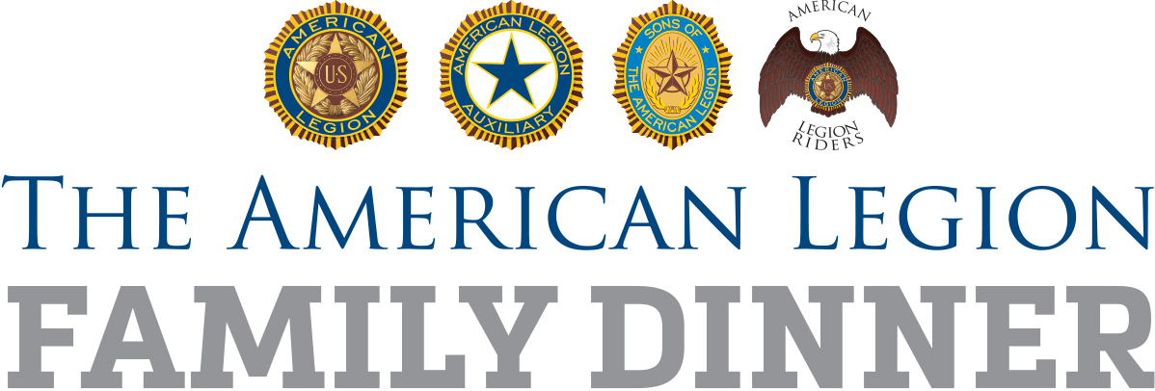

Suggested Timeline
Legion Family Dinner Planning

Here is a suggested timeline to plan and promote Legion Family Dinners in local communities. These dinners can be held in conjunction with the Legion’s birthday, your post’s birthday, Memorial Day, Veterans Day, Thanksgiving, Christmas and more. For questions about the dinner project, email magazine@legion.org.

As Soon As Possible:

- Reach out to department and/or district to invite leadership to attend the Legion Family Dinner. If a department or district representative attends, see if they would like to participate in speaking and/or welcoming the guests as part of the program.
- Legion Family leaders should get together to outline the best way the post/unit can deliver a bigger and better Family First! Veterans Day Dinner, assign responsibilities and set deadlines for accomplishment.
- Identify specific groups/people from the community to invite, such as law enforcement officials, school teachers, National Guard families, Military Family Support Groups, Scouts and college veterans associations
- Determine how best to incorporate into the dinner the centennial message, and history of post, interesting figures, displays, traditions, etc.
- Make a list of possible local sponsors who may be able to offer funds or food and decide how best to recognize them at the event and in media.
- Specify logistics of the event itself (menu, pricing, advance reservations)
- Develop a media plan to promote event, using local outlets, fillable flyer (included at www.legion.org/nalpa/resources), and social media
- Identify opportunities to make the dinner an opportunity for membership recruitment, fundraising or basic awareness of what the Legion Family does
- Enlist the help of local American Legion youth program participants, their coaches and instructors; consider offering them a percentage of the dinner proceeds

Oct. 1:
- Finalize logistics – place, time, menu, estimate of numbers, promotional budget, volunteer staffing needs and clean-up.
- Prepare a message for the dinner that emphasizes both current services and post history, to go along with the centennial.
- Decide if funds from the dinner can be used to help a specific cause, such as restoration of a veterans memorial, support for a youth program, flag purchases for the community, or other opportunities.

Oct. 1 – Oct. 15:

- Invite groups in the community to the dinner and begin collecting a reservation count in order to plan accordingly for numbers.
- Explore opportunities to serve free or discounted meals to homeless veterans, those at long-term care facilities or others in the community who might feel isolated on Veterans Day.
- Pursue local sponsorship opportunities, such as donations of food items or funds, to help offset the cost of this expanded dinner.
- Begin implementing media plan; emphasize advance reservations and the Legion Family’s passion to share with the community all the good the post does.

Oct. 15:
- Review media plan, adjust as needed to reach the desired audiences, encourage advance reservations, and deliver the message – preferably in person – to local media managers and editors.
- Complete the fillable flyers and begin posting them.
- Begin social media announcements, which can continue on a regular basis as the event nears. Use hashtag #LegionFamilyDinner
- Announce plans for your event on your website, social media channels and submit a story on the national website, www.legion.org/legiontown

Nov. 1:
- Prepare the post or event venue for the dinner, with a focus on the Legion’s “Legacy and Vision,” how programs through the local post history continue to improve lives today. Consider a display of post artifacts and treasures or a speech/presentation about the post namesake, particularly if the namesake is a World War I casualty, in this year of the U.S. centennial of the war that led to the formation of The American Legion.

Nov. 11:
- Conduct the dinner event.
- Take photos, shoot video, report success and post on social media channels, as it happens and immediately afterward. Use hashtag #LegionFamilyDinner
- Report attendance and participation, not only to the post members but to those in the community at large so they will be interested in future years

After the dinner:

- Report your post’s Family First! Veterans Day Dinner success at www.legion.org/legiontown
- Prepare and deliver an article with photos for the post, district or department newsletter, website or social media channels
- Get feedback from Legion Family members and other invited groups to determine how the dinner can grow and improve in future years.
- Follow up with attendees to see if they are interested in joining The American Legion Family or supporting in other ways.
- Have an after-action meeting, or make an after-action report part of the post meeting, to go over the numbers and what the dinner achieved in terms of local awareness.

