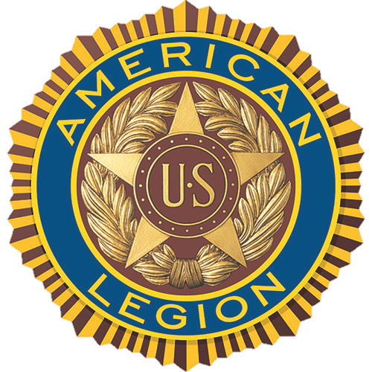

SOCIAL MEDIA POSTS

SAMPLE FACEBOOK POST

Veterans in the (CITY, STATE) area: The American Legion is hosting a town hall meeting tonight to hear your health care experiences at the (NAME OF VA MEDICAL FACILITY). The town hall meeting begins at (TIME) (DAY), (MONTH/DATE), at (LOCATION), (STREET ADDRESS, CITY). All veterans receiving care at the (NAME OF VA MEDICAL FACILITY) are invited to attend and share their experiences. American Legion representatives and VA staff will be on hand to answer questions.

SAMPLE TWITTER POST

(STATE) #veterans: Discuss @VeteransHealth care (TIME) (DAY), (MM/DD) at our town hall, (LOCATION)

(ADD TAGS TO APPROPRIATE PARTIES, SUCH AS POST, DISTRICT AND DEPARTMENT LEGION TWITTER FEEDS, VA FACILITY FEEDS AND LOCAL LEGISLATORS)

