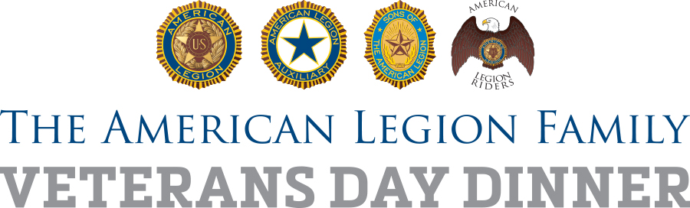

Family First! Veterans Day Dinner Suggested Message Points
on The American Legion

(for publicity, media interviews, remarks during dinner, etc.)

On the national level:

- The American Legion is nearing its 100th anniversary. It was founded in March 1919 in Paris, France, by U.S. World War I military personnel stationed there who were dedicated to four pillars of service: veterans, national security, youth and patriotic values.
- The American Legion today consists of 55 “departments” in each of the 50 states as well as the District of Columbia, France, Mexico, the Philippines and Puerto Rico. There are approximately 13,000 local posts worldwide. It is the nation’s largest veterans service organization.
- Current national American Legion membership is 2 million. Combined with the American Legion Auxiliary and Sons of The American Legion, membership in what is known as The American Legion Family exceeds 3 million altogether.
- American Legion membership is open to military personnel and veterans who have served their nation on active duty during wartime. Eligibility has been open to all who have served on active duty since Aug. 2, 1990, the beginning of continuous U.S. armed conflict in the Middle East and other locations around the planet.
- The American Legion has been instrumental in the creation of a number of major institutions of American society, including formation of the Department of Veterans Affairs, U.S. Flag Code, writing and passing the GI Bill and successfully fighting for adequate care for veterans suffering with such wartime conditions as post-traumatic stress disorder and those connected to Agent Orange exposure.
- Accredited American Legion service officers are working on approximately 750,000 benefits claims cases for veterans, free of charge, at any one time, year-round.
- The American Legion works daily in Washington to improve VA health care, benefits delivery, employment and business opportunities for veterans.
- The American Legion works daily in Washington and at the Pentagon to ensure our nation’s troops are adequately equipped, rewarded for their service and given a reasonable quality of life for their families.
- The American Legion serves thousands of young people a year through such programs as Boys Nation, American Legion Baseball, Junior Shooting Sports, Youth Cadet Law Enforcement, Boy Scout sponsorship, Oratorical Competition and Junior ROTC.

American Legion Posts around the nation:

- Fulfill more than 3.7 million hours of volunteer service in their communities per year
- Donate more than 80,000 pints of blood to collection centers nationwide, which makes The American Legion the nation’s single largest blood donor
- Awards more than 8,000 medals to Junior ROTC students
- Sponsors more than 2,500 Scouting units serving more than 64,000 young people
- Awards more than $4 million in college scholarships

Centennial:

- The American Legion will mark its 100th anniversary with a 15-month celebration running from its national convention in August 2018 through Veterans Day 2019.
- The Legion’s 100th Anniversary mantra is “Legacy and Vision” – both a celebration of past accomplishments and a renewal of the organization’s resolve to serve communities, states and the nation for a second century.
- Centennial initiatives of note include collection and housing of a worldwide database of memorials and monuments to military and veterans, participation in a national grant program to restore and raise awareness of local World War I memorials, connections with post-9/11 generation veterans groups on multiple projects, and more.

Post Message Points

Local post message are succinct, fact-based clauses or sentences that provide information you can easily share with others, such as the media. Posts are encouraged to create their own, featuring local historical facts, activities, programs and services. After completion, they can be saved for future use.
A few questions you can ask yourself as you prepare local post message points include:

Who is the post namesake and what is his or her story?
Who founded the post, and when?
Who are some notable members in your post’s history?
Who are some notable alumni of your youth programs?
What are some important dates in the history of your post, and why are they important?
What community organizations has your post associated with over the years?
What community service roles does your post play now, or has it played in the past?
What great things has your post done for your community, such as the construction of war memorials, sponsorship of Scouting units, presentation of the Colors at local patriotic events and activities, involvement in School Awards programs, scholarships and more?
What is your post’s vision for the future and what are you doing to get younger veterans involved The American Legion?

