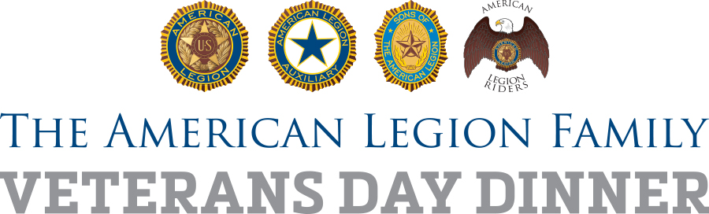

For Immediate Release [Date]

American Legion Post (POST NUMBER) to serve Family First! Veterans Day dinner for community

(CITY) (MONTH DATE, YEAR) – To celebrate Veterans Day this year, American Legion Post (POST NUMBER) in (CITY) is planning a bigger-than-ever dinner event and inviting the entire community.

American Legion National Commander Denise H. Rohan has asked the Legion Family around the world to put into action her theme of “Family First!” by inviting the community to join them for Veterans Day on Saturday, Nov. 11.

Post (POST NUMBER), named for (NAMESAKE), currently numbers XXX members plus XXX in the affiliated American Legion Auxiliary and Sons of The American Legion. It was founded in (YEAR). Among those whose lives have been touched by Post (POST NUMBER) are: (BOYS STATE ALUM, BASEBALL PLAYER, FAMILY, SOLDIER, PUBLIC OFFICIAL, ETC.)

(PROVIDE DETAILS OF DINNER; WHAT, WHERE AND WHEN; ANY COST) The dinner is provided with help from (LIST VOLUNTEER GROUPS, SPONSORS).

“The American Legion Family of (POST and UNIT) is excited to open our doors to the community this Veterans Day,” Post (POST NUMBER) Commander (FULL NAME) said. “This event will not only honor veterans and their families, but emphasize our past, present, and future of service to the community.”

Let Post (NUMBER) know you’ll be there by contacting (NAME, PHONE NUMBER, EMAIL ADDRESS).

#LegionFamilyDinner

###

