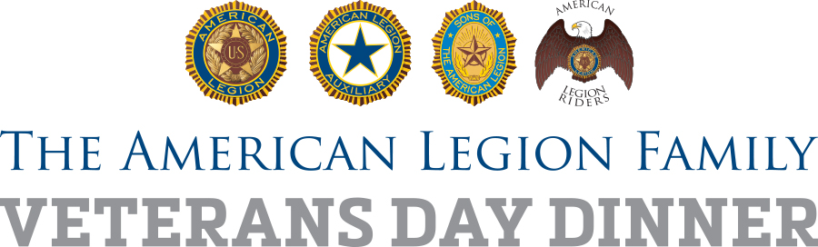

Family First! Veterans Day Dinner
Sample 30-Second Radio Spot

On Saturday, Nov. 11, (NAMESAKE) American Legion Post (NUMBER) in (CITY) serves up a Family First! Veterans Day dinner, bigger and better than ever, and the whole community is invited to celebrate the power of family – the American Legion Family, local veterans, military families, first responders, youth groups and all others.

Join us at (LOCATION) at (TIME, AM/PM)

Come learn about our legacy of service, and hear about The American Legion’s vision for the future.

#LegionFamilyDinner

###

