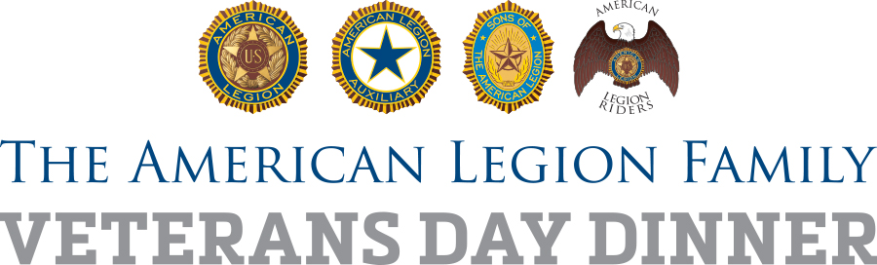

Social media posts

[Good for local Facebook, Twitter, Instagram, feeds; amend as needed/required by platform restrictions]

FACEBOOK

Honor those who have served our nation at (NAMESAKE) American Legion Post (POST NUMBER) in (TOWN). The whole community is invited to our bigger and better than ever Family First! Veterans Day Dinner! Saturday, Nov. 11, (TIME), at the post, (ADDRESS). #LegionFamilyDinner

TWITTER

Honor military service @AmericanLegion Post (POST NUMBER) in (TOWN). Family First! Dinner Sat., 11/11/17, (TIME), at (LOCATION). #LegionFamilyDinner

