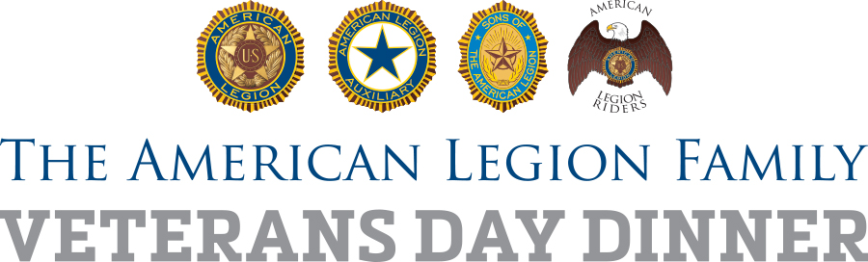

Local sponsorships can help

American Legion posts and Auxiliary units can pursue local sponsorship opportunities, such as donations of food items or funds, to help offset the cost of serving up a bigger-than-ever Veterans Day dinner in 2017 and future events.

By visiting local businesses and potential sponsors, members of The American Legion Family can also promote how the local post serves the community and build awareness of the organization’s coming centennial.

It’s important to remember that sponsorship funds and other donations are not filling operational budgets but are being used to help and honor veterans, troops and youth, and to promote patriotism in your community.

A local business may be interested in assisting if needy members of the community, such as homeless veterans or those in long-term care, will be provided free meals on Veterans Day.

Remember that when you ask for donations or volunteers, you also should invite the managers and employees of the company to come to the event and share in the experience.

Even if the business does not commit to help this year, thank them for their consideration and visit them again soon to explain how the event went.

For those who do commit funds or volunteers, be sure to recognize them in promotional materials such as flyers, releases and radio spots. Following that, a thank you letter from the post commander to the business owner or manager is important.

And in future events, dinner sponsors can be listed in programs or otherwise recognized at local post events.

