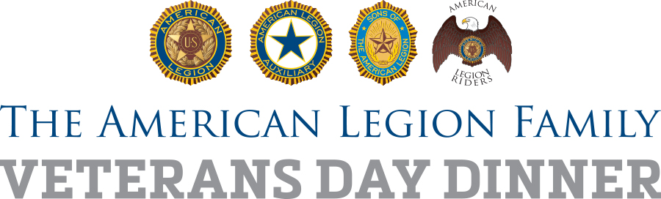

Suggested Timeline
Family First! Veterans Day Dinner Planning

Here is a suggested timeline to plan and promote this year’s “bigger and better” Family First! Veterans Day Dinner in local communities. For questions about the Veterans Day Dinner project, email magazine@legion.org.

As Soon As Possible:

- Legion Family leaders should get together to outline the best way the post/unit can deliver a bigger and better Family First! Veterans Day Dinner, assign responsibilities and set deadlines for accomplishment.
- Identify specific groups/people from the community to invite, such as law enforcement officials, school teachers, National Guard families, Military Family Support Groups, Scouts and college veterans associations
- Determine how best to incorporate into the dinner the centennial message, and history of post, interesting figures, displays, traditions, etc.
- Make a list of possible local sponsors who may be able to offer funds or food and decide how best to recognize them at the event and in media.
- Specify logistics of the event itself (menu, pricing, advance reservations)
- Develop a media plan to promote event, using local outlets, fillable flyer (included at www.legion.org/nalpa/resources), and social media
- Identify opportunities to make the dinner an opportunity for membership recruitment, fundraising or basic awareness of what the Legion Family does
- Enlist the help of local American Legion youth program participants, their coaches and instructors; consider offering them a percentage of the dinner proceeds

Oct. 1:
- Finalize logistics – place, time, menu, estimate of numbers, promotional budget, volunteer staffing needs and clean-up.
- Prepare a message for the dinner that emphasizes both current services and post history, to go along with the centennial.
- Decide if funds from the dinner can be used to help a specific cause, such as restoration of a veterans memorial, support for a youth program, flag purchases for the community, or other opportunities.

Oct. 1 – Oct. 15:

- Invite groups in the community to the dinner and begin collecting a reservation count in order to plan accordingly for numbers.
- Explore opportunities to serve free or discounted meals to homeless veterans, those at long-term care facilities or others in the community who might feel isolated on Veterans Day.
- Pursue local sponsorship opportunities, such as donations of food items or funds, to help offset the cost of this expanded dinner.
- Begin implementing media plan; emphasize advance reservations and the Legion Family’s passion to share with the community all the good the post does.

Oct. 15:
- Review media plan, adjust as needed to reach the desired audiences, encourage advance reservations, and deliver the message – preferably in person – to local media managers and editors.
- Complete the fillable flyers and begin posting them.
- Begin social media announcements, which can continue on a regular basis as the event nears. Use hashtag #LegionFamilyDinner
- Announce plans for your event on your website, social media channels and submit a story on the national website, www.legion.org/legiontown

Nov. 1:
- Prepare the post or event venue for the dinner, with a focus on the Legion’s “Legacy and Vision,” how programs through the local post history continue to improve lives today. Consider a display of post artifacts and treasures or a speech/presentation about the post namesake, particularly if the namesake is a World War I casualty, in this year of the U.S. centennial of the war that led to the formation of The American Legion.

Nov. 11:
- Conduct the dinner event.
- Take photos, shoot video, report success and post on social media channels, as it happens and immediately afterward. Use hashtag #LegionFamilyDinner
- Report attendance and participation, not only to the post members but to those in the community at large so they will be interested in future years

After the dinner:

- Report your post’s Family First! Veterans Day Dinner success at www.legion.org/legiontown
- Prepare and deliver an article with photos for the post, district or department newsletter, website or social media channels
- Get feedback from Legion Family members and other invited groups to determine how the dinner can grow and improve in future years.
- Follow up with attendees to see if they are interested in joining The American Legion Family or supporting in other ways.
- Have an after-action meeting, or make an after-action report part of the post meeting, to go over the numbers and what the dinner achieved in terms of local awareness.

