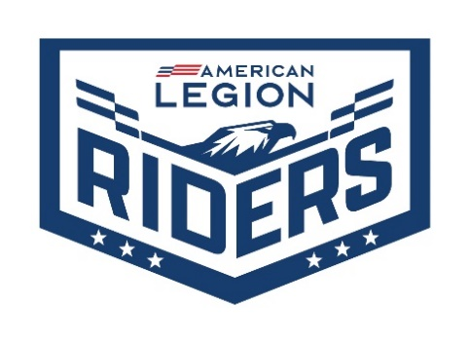

Contact: (Your Name)
Phone: (Your Phone)
Email: (Your Email)

FOR IMMEDIATE RELEASE

American Legion Legacy Run To Pass Through [LOCATION] On August [DATE], 2022
Annual Cross-Country Ride Supports Children Of Post 9/11 Era Veterans.

INDIANAPOLIS - More than 250 motorcycles are expected to pass through [LOCATION] on August [DATE], 2022, at approximately [TIME] as part of The American Legion Legacy Run. This five-day, 1,150-mile, cross-country motorcycle ride raises awareness and funds for the American Legion Legacy Scholarship, which supports the children of fallen military personnel and the children of disabled veterans who served in the post 9/11 era. The Legacy Run is one of the largest and longest organized motorcycle group rides in the United States.

The full American Legion Legacy Run will begin August 21, 2022 at the USS Alabama Battleship Memorial Park in Mobile, Alabama. It will conclude at the American Legion Post 434 in Oak Creek, Wisconsin on August 25, 2022, where Medal of Honor Recipient Gary Wetzel will welcome the riders after traveling 1,150 miles across seven states over five days. The ride will stop at monuments, memorials and American Legion posts in Lauderdale County and Tupelo, MS, Humboldt, TN, Mayfield and Paducah, KY, Perryville, MO, St. Libory, Bloomington and Marseilles, IL, and Union Grove before ending in Oak Creek, WI.

Now in its 16th year, The American Legion Riders have raised more than $15 million, including $1.14 million in 2021 for The American Legion Legacy Scholarship Fund. The fund provides college scholarships to children of U.S. military personnel killed while serving on active duty on or after September 11, 2001, and children of post-9/11 veterans with a combined Department of Veterans Affairs disability rating of 50 percent or higher. Since 2004, the Legacy Scholarship Fund has awarded 478 scholarships, totaling more than $4.7 million.

During each stop, the American Legion National Commander Paul E. Dillard ,will be on hand to collect donations for the Legacy Scholarship Fund and will be available to discuss the Legacy Run and The American Legion with the community and local media. Accompanying Commander Dillard are Sons of The American Legion National Commander Michael Fox and The American Legion Auxiliary National President Kathy Daudistel.

The American Legion is asking anyone who is on or near the travel route or any of the memorial destinations to show support by raising their flags and/or lining the route as more than 250 motorcycles pass through their local community riding for the children of our nation’s heroes.

About The American Legion
The American Legion, the nation’s largest veterans organization, is dedicated to the motto of “Veterans Strengthening America.” Chartered by Congress in 1919, The American Legion is committed to mentoring youth and sponsoring wholesome community programs, advocating patriotism and honor, promoting a strong national security and continued devotion to servicemembers and veterans. Nearly 2 million members in more than 12,600 posts across the nation and regions overseas serve their communities with a devotion to mutual helpfulness. The American Legion Riders of Legion family members is a program with over 2,500 chapters in Legion Posts worldwide with over 125,000 members.

National Haedquarters Indianapolis, IN: legacyrun@legion.org
More information about the Legacy Run: https://www.legion.org/riders/legacyrun.
More information about The American Legion Riders: https://www.legion.org/riders.
More information about The American Legion Scholarship Fund: https://www.legion.org/scholarships/legacy
To donate to the Legacy Scholarship and other American Legion charities fund: https://mylegion.org/PersonifyEbusiness/Donate#legion-org
For local information contact: [YOUR CONTACT INFORMATION]

# # #

